Tracking active uptake of minerals by plant roots

The purpose of this investigation was to investigate active transport, that is, a process that uses energy to transport useful substances across cell membranes. In this case, the useful substance is sulfate ions and the cell membranes are in the roots of plants.

Procedure
Read the account of an investigation of active transport performed by scientists some years ago. Study the data that resulted from their investigation and then answer the questions that follow.
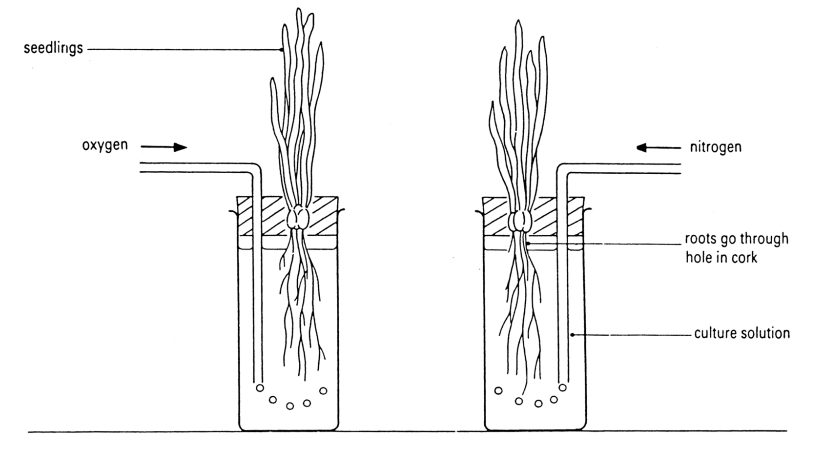

Investigation
- Two similar groups of barley seedlings were grown from seed in a culture solution. The culture solution contained all the ions necessary for plants to grow. The sulfate ions in the solution contained radioactive sulfur atoms – ³⁵S.
- During the investigation, oxygen was bubbled through the solution containing one group of seedlings. Pure nitrogen was bubbled through the solution containing the other group of seedlings. Nitrogen gas is not harmful to seedlings, but bubbling it through the culture solution removes all the oxygen from the culture solution.
- The amount of radioactive sulfate ions in each culture solution was measured at the start of the experiment, and then every half-hour for 4 hours.
- The investigators subtracted the amount of radioactive sulfate ions remaining in each solution from the amount that was there at the start of the experiment. They assumed that the difference between the two figures showed the amount of sulfate ions that had been taken into the plant tissues.
- This table shows the results for each solution.

Time (minutes) | Total amount of sulfate ions absorbed (arbitrary units)
 | With oxygen (aerobic) | With nitrogen (anaerobic)
0 | 0 | 0
30 | 220 | 140
60 | 290 | 190
90 | 350 | 210
120 | 390 | 225
150 | 430 | 238
180 | 490 | 250
210 | 500 | 260
240 | 530 | 290
- Plot a graph of these results, with time (in minutes) on the horizontal axis.

QUESTIONS
- What is the independent variable in this investigation?

- What is the dependent variable?

- Name two variables the scientists should have controlled in the procedure.

- How would the scientists have made their results reliable?

- In which solution did the barley take up more sulfate ions?

- Make a statement that links the amount of sulfate ions taken up to the amount of oxygen available to the plant.

- If there is a higher concentration of sulfate in the culture solution than inside the cells of the roots, what will happen to the sulfate?

- What process in living things uses oxygen? This process is going on in the roots of these plants.

- Giving the roots plenty of oxygen affects the uptake of sulfate ions. How do you think this works?

- Active transport of ions is different from diffusion because the ions move up their concentration gradient. What do you think this means?

- Use the ideas you have developed from this investigation to explain each of the following observations:
- Over-watering pot plants may kill them.
- Many fields cannot be used to grow crops successfully unless drainage ditches are dug around them and drainage pipes laid through them.
- The species of plants that grow most successfully in bogs and marshes are different from the species of plant that grow in dry grassland.

ANSWERS
- The independent variable in this investigation is the gas bubbled through the solution.

- The dependent variable is the amount of sulfate ions absorbed.

- Two controlled variables should be the size of the seedlings and their state of health, or the amount of culture solution, the concentration of culture solution, the humidity and light around the seedlings.

- The scientists would have made their results reliable by repeating the experiment on more than one occasion with a number of barley seedlings.

- The barley takes up more sulfate when oxygen is bubbled through the culture solution.

- More sulfate ions are taken up when more oxygen is available to the plant.

- If there is a higher concentration of sulfate in the culture solution than inside the cells of the roots, and the membrane is permeable to sulfate, then sulfate could diffuse through the cell membrane into the tissues.

- The process in living things that uses oxygen is called respiration. This process is going on in the roots of these plants.

- When the roots have plenty of oxygen, they can respire and convert energy stored in glucose to a form that is useful within cells (ATP). The ATP can then work with membrane transporter proteins to pull sulfate into the cells.

- Active transport of ions is different from diffusion because the ions move up their concentration gradient. This means that the ions move from areas of low concentration to areas of high concentration. This process would require an input of energy (a kind of chemical pump).

- Ideas from this investigation could explain each of the following observations:
- Over-watering pot plants may kill them: This could be because too much water means the soil is waterlogged and not fully aerated. Less air (which includes oxygen) around the roots might mean that aerobic processes can no longer occur and the root tissue may die and rot.
- Many fields cannot be used to grow crops successfully unless drainage ditches are dug around them and drainage pipes laid through them: As above, waterlogged soil contains fewer air-filled spaces. Without air for respiration, plant tissues may die and rot.
- The species of plants that grow most successfully in bogs and marshes are different from the species of plant that grow in dry grassland: Any plant that grows naturally in boggy ground must have adaptations that allow it to cope with limited gaseous oxygen around its roots. Plants that grow in dry grassland will have adaptations that depend on dry air spaces in the soil for their survival.

