Recording variation in ivy leaves

The purpose of this activity is:
- to make observations of a plant in its natural habitat, and of its habitat
- to develop hypotheses that might explain the variation between the leaves of plants of the same species growing in different conditions
- to plan how to collect data to test your hypothesis
- to collect and analyse data about plant leaves and environmental factors

Procedure
SAFETY:
Wash your hands after handling plant material or soil, and let your teacher know if your skin is often sensitive to plant material.
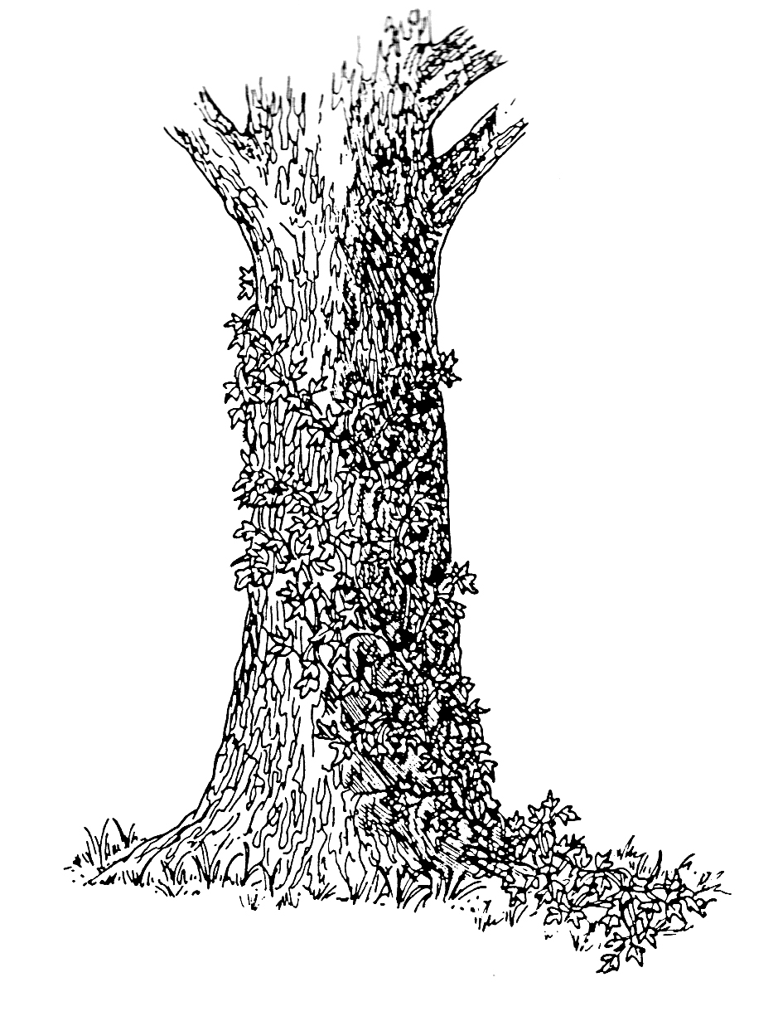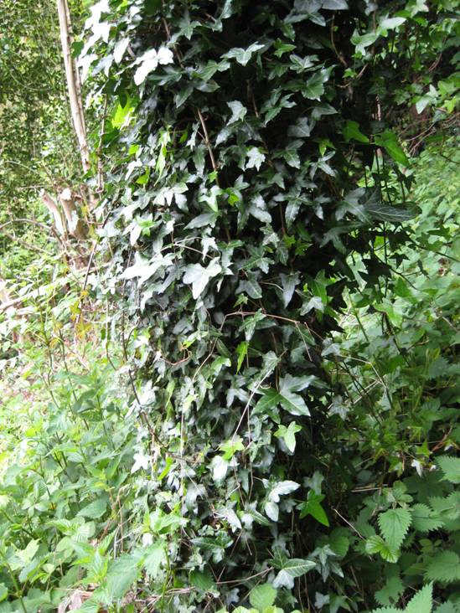
The same ivy plant may grow along the ground and up the trunk of a tree. This means that the growing conditions for different parts of the plant are very different. You can compare leaves by measuring their width and the length of their leaf stalks (petioles).

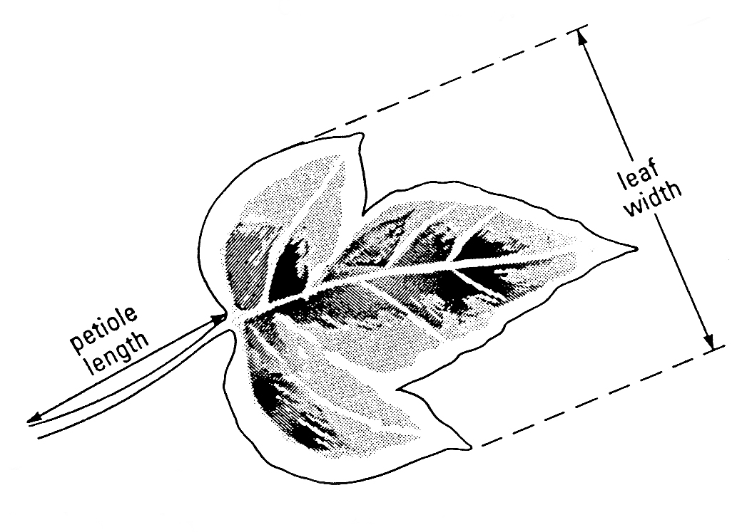
Think about what variables might affect the growth of ivy leaves. If possible, make some preliminary observations by looking at ivy growing in different situations in your school grounds or your garden at home.

Investigation
- What question would you like to answer? What do you think the answer to your question will be?

- Where will you collect ivy leaves to find the answer to your question?

- How will you decide:
- which leaves to pick?
- how many leaves to collect and measure to get reliable results?
- exactly what to measure?
- which environmental factors to measure?
- how to record your measurements?

- Check your plan with your teacher before going ahead.

QUESTIONS
- Display your data to show any patterns in the results.

- Have your data answered your question?

- Can you explain your results, using what you know about what plants need to grow?

- Do your results suggest that differences in the environment influence the growth of ivy leaves?

ANSWERS
- This will depend on the results.

- You might find longer petioles on leaves that are in shadier regions, or shorter petioles on leaves in dry or windy conditions.

- Plants will grow better in damp, light conditions (where they are not shaken about too much by the wind). ‘Better’ might not simply be a measure of the size of individual leaves – a plant could make a few large leaves or many small leaves if it is growing quickly and well. Leaves growing closer together (and close to the supporting structure) will lose less water. Larger leaves have a greater surface area to absorb light.

- This relationship could be complicated. But that is what makes it a useful subject for investigation like this. If you find there is no difference between two samples of leaves, it is still useful to know that the conditions in two places are not sufficient to cause a variation in the size or proportions of the ivy leaves.

