Observing patterns in the distribution of a simple plant
The purpose of this activity is:
- to develop skills using a quadrat
- to investigate the distribution of a plant in our local environment

Procedure
SAFETY:
Take care walking around the trees and look out for anything hazardous in the area. Take particular care and be aware of traffic if you are working near a road. If it is a sunny day, apply suncream or wear suitable clothing. Wash your hands thoroughly after touching the trees.

Investigation
- Have a close look at the trunks of trees in your school grounds or in your garden at home. Look for a green powdery growth that is evidence of the presence of tiny single-celled plants called Pleurococcus growing on the trunk.
- Find out which direction is North – using a map or compass or information from your teacher. Try to identify the direction from which the wind usually blows. This is called the ‘direction of the prevailing winds’.
- Draw how the base of the tree trunk looks from the north and the south. Show where the Pleurococcus is growing by shading on your drawing. Look closely. If you think the green patches are more dense in some areas than others, shade those areas a little darker on your drawing.
- Take your piece of string marked at 10 cm intervals. Fix it around the trunk of the tree about 1–1.5 m above the ground (above dog height!).
- Place a 10 cm x 10 cm quadrat on the string at one point. Estimate the density of Pleurococcus by estimating the percentage of bark under the quadrat that is covered in it.
- Move the quadrat along as shown in this diagram, and repeat your estimation.

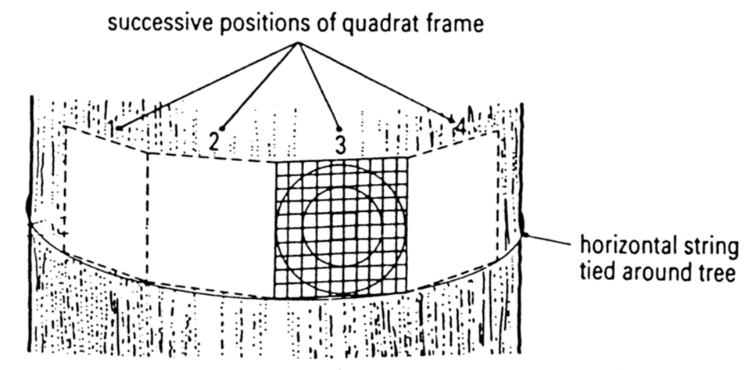

- Display your results as a bar chart. Show percentage cover against aspect. (Aspect means the direction the patch of tree trunk faces.)

Questions

- Where does the Pleurococcus grow? Is it on vertical or horizontal surfaces, in the sun or in the shade, on a tree standing by itself, or shaded by other trees or buildings?

- What conditions do you think Pleurococcus needs to live? Where does it get the things it needs?

- How would environmental conditions, especially light and water, vary around the tree during the course of a day?

- What does your bar chart tell you about the patchy distribution of this plant?

- Can you think of a better way to present your results than a bar chart?

Answers

- Where does the Pleurococcus grow? This answer will vary according to the students’ observations.

- Pleurococcus is an alga, a single-celled plant. It needs light and water (containing mineral nutrients) to live, as well as carbon-dioxide from the air. It will get light from the sun, water from rainfall landing on tree bark (rather than absorbed from the tree’s internal water supply systems) and carbon-dioxide from the air. It needs the right kind of surface to grow on, too – rough enough to be able to take hold.

- Environmental conditions vary around the tree during the course of a day – with light being strongest in the direction of the sun at any point, and water depending on rainfall but also on sunlight and wind. When the sun shines brightly, or a dry wind blows, the side of the tree exposed to sun or wind will be dryer.

- The bar chart will vary according to the students’ results.

- Presenting the bars from a central point, or drawing a line of varying distance (in proportion to algal density) from a circle (that represents the bark of the tree) might make it easier to interpret and compare the results.

