Investigating the effect of amylase on a starchy foodstuff
By working through this practical you will learn that:
- investigate enzyme action on a foodstuff
- see that food must be digested before it can be absorbed in the digestive system
- evaluate a model for the process of digestion

Procedure
SAFETY: Take care with very hot water.
Wear eye protection when handling chemicals.
Investigation
- Label 3 boiling tubes 1, 2, 3.
- Label 3 test tubes 1, 2, 3.
- Set up 3 model guts: take a wet piece of Visking tubing, tie a knot in one end, place the sawn off syringe barrel in the other end and secure with an elastic band. These may have been set up for you (see diagram).
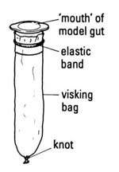
- Use the spatula to add rice to each of the model guts until they are half full.
- Rinse the outside of each piece of Visking tubing under a running tap.
- Place the rice-filled model gut in a labelled boiling tube half-filled with warm water (see diagram).

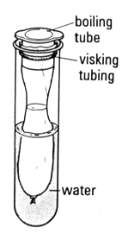
- Immediately withdraw one drop of the water you have added and test it with iodine on a dimple tile.
- Add 5 cm³ of water to model gut 1.
- Add 5 cm³ of amylase to model gut 2.
- Add 5 cm³ of boiled amylase to model gut 3.
- Place all the boiling tubes containing the model guts in the water bath at approximately 37ºC.

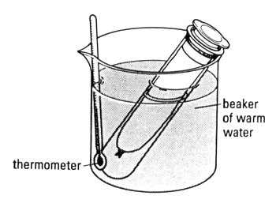
- Leave for at least 15 minutes.
- While you are waiting:
- Place a grain of rice in a well on the white tile and add a drop of iodine. A blue-black colour indicates that starch is present.
- Put some rice in a test tube. Add 2 cm³ of water, 2 cm³ of Benedict’s reagent and place into a large beaker of boiling water. Check the colour after 2-3 minutes. An orange (or greeny-yellow) colour indicates that glucose or a similar sugar is present.
- Record your results in a suitable table.
- After 15 minutes, use a teat pipette to remove some of the water surrounding the model gut in boiling tube 1.
- Place one drop of this water in a well of the white tile and add a drop of iodine. Record the result.
- Place the rest (around 2 cm³) of the water from boiling tube 1 into test tube 1. Add 2 cm³ of Benedict’s reagent and place test tube 1 into a large beaker of boiling water. Check the colour after 2-3 minutes. Record the result.
- Repeat steps n, o, p with water from boiling tubes 2 and 3. Record the results.

QUESTIONS
- What does the Visking tubing of the model gut represent?

- What does the water in the boiling tube, outside the model gut, represent?

- How is this model different from the situation in a real gut?

- What has happened to the starch in each of your tubes?

- What has happened to sugars (detected with Benedict’s reagent) in each of your tubes?

- Use the diagram to explain what is happening in each of the 3 model guts.

- Why does the body need enzymes to digest food?
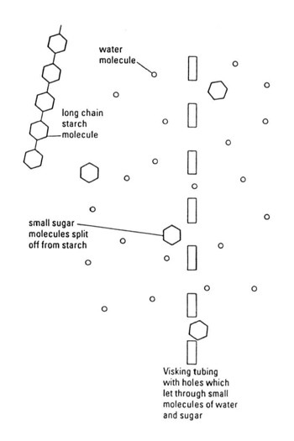
- What is your result with boiled amylase? Try to explain this.

ANSWERS
- The Visking tubing of the model gut represents the wall of the small intestine.

- The water in the boiling tube outside the model gut represents blood in the blood vessels around the intestine.

- In a real gut, food is moving through the tube, blood is circulating around the blood vessels and carrying away the absorbed food chemicals, the gut lining is folded into villi and microvilli, there are mechanisms that can actively absorb some food chemicals, there is a more complicated mixture of food and enzymes in the intestine, the pH of the gut contents is controlled by gut secretions etc.

- In each case, there is still starch inside the gut, but no starch in the water outside.

- In tubes 1 and 3, there is no sugar either inside or outside the gut. In tube 2, there is sugar inside and outside the gut.

- In each case there is starch in the gut, but not outside, because the starch molecules are too large to pass through the holes in the Visking tubing/ gut wall. In tube 2, the enzyme amylase has broken down some of the starch to sugar and some of the smaller sugar molecules have been able to pass through the holes in the Visking tubing/ gut wall.

- The body needs enzymes to digest food because large polymer food molecules are too large to pass through the gut wall. Chemical digestion without catalysts is too slow to be useful. Specifically, we need glucose (and other sugars) as a ready source of energy in our bloodstream.

- The boiled amylase has had no effect on the starch in the rice because it is has been denatured by the high temperature. This means the protein molecule has lost its shape and can no longer work as a catalyst for breaking down starch to sugar.

