Investigating an enzyme controlled reaction: catalase and hydrogen peroxide concentration
Objectives
- to investigate the effect of substrate concentration on the activity of catalase
- to evaluate a practical protocol

Procedure
SAFETY:
Wear eye protection and protect clothing from hydrogen peroxide. Rinse splashes of peroxide and pureed potato off the skin as quickly as possible...

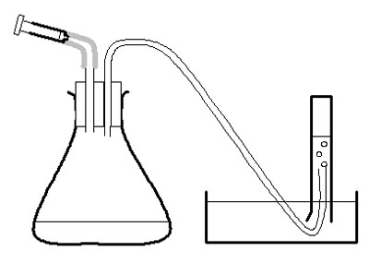

Investigation
- Use the large syringe to measure 20 cm³ pureed potato into the conical flask.
- Put the bung securely in the flask – twist and push carefully.
- Half-fill the trough, bowl or sink with water.
- Fill the 50 cm³ measuring cylinder with water. Invert it over the trough of water, with the open end under the surface of the water in the bowl and with the end of the rubber tubing in the measuring cylinder. Clamp in place.
- Measure 2 cm³ of hydrogen peroxide into the 2 cm³ syringe. Put the syringe in place in the bung of the flask but do not push the plunger straight away.
- Check the rubber tube is safely in the measuring cylinder. Push the plunger on the syringe and immediately start the stopclock.
- After 30 seconds, note the volume of oxygen in the measuring cylinder in a suitable table of results.
- Empty and rinse the conical flask and measure another 20 cm³ pureed potato into it. Reassemble the apparatus, refill the measuring cylinder, and repeat from d to g with another concentration of hydrogen peroxide. Use a 100 cm³ measuring cylinder for concentrations of hydrogen peroxide over 20 vol.
- Calculate the rate of oxygen production in cm³/ s.
- Plot a graph of rate of oxygen production against concentration of hydrogen peroxide.

QUESTIONS
- Apart from oxygen, what product is made when hydrogen peroxide breaks down?

- Identify any anomalies or inconsistencies in your results.

- Describe the shape of the graph.

- Explain the shape of the graph in relevant biological terms.

- Describe any technical difficulties you had with this apparatus and explain how these could be overcome.

- Describe how you would extend this investigation to provide more evidence/ data to support your understanding of enzyme-controlled reactions.
ANSWERS
- Apart from oxygen, water is made when hydrogen peroxide breaks down.

2H₂O₂ 2H₂O + O₂

- Students may identify some anomalies or inconsistencies in their results. They should be able to explain what to do with them.

- At low concentrations, the graph will show an increasing rate of reaction as concentration increases, levelling off at higher concentrations.

- The shape is explained by the concentration of substrate directly affecting the rate of reaction until another limiting factor becomes more important.

- Students should be able to describe technical difficulties and suggest how these could be overcome.

- Further investigations could investigate other possible limiting factors, such as temperature, pH, or concentration of enzyme.

