Interpreting an investigation of plant hormones

The purpose of this activity is:
- to evaluate an investigation of plant hormones
- to develop an understanding of how plant hormones control their growth

You might have noticed plants growing like those in this picture.
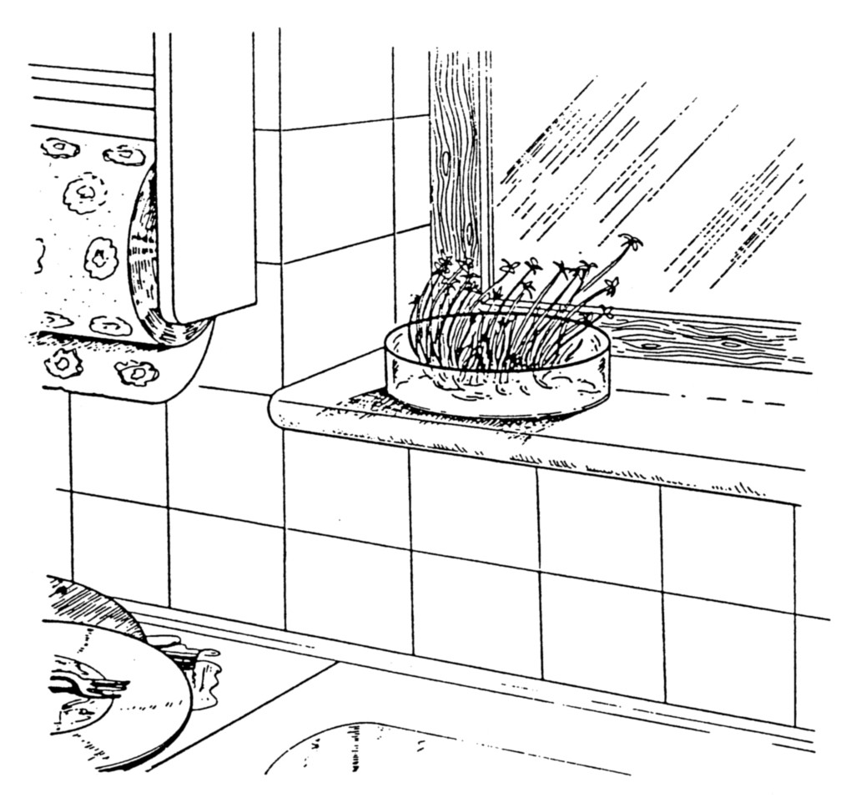
These seedlings are growing towards the light – their stems are bent and their leaves are facing the sunlight in a way that exposes as much of the leaf as possible to the light. They are showing a “growing-toward-the-light-tendency” which biologists call “positive phototropism”. The “positive” part indicates that they are growing towards the light. The “photo-“ part refers to light. And the “-tropism” indicates that it is a response involving how the plant is growing. This is a case of plants responding to a stimulus – the stimulus is light and the response is how they grow.

Procedure
The investigations described below are examples of work that has been done to try to work out how positive phototropism happens.
The seedlings used in these investigations were cereals, such as barley. The shoots do not look the same as cress seedlings. They seem to have no leaves; but in fact the early shoots are closed tubes with long narrow leaves inside. This kind of shoot is called a coleoptile.
Read through each example and try to interpret the results.

Investigation 1

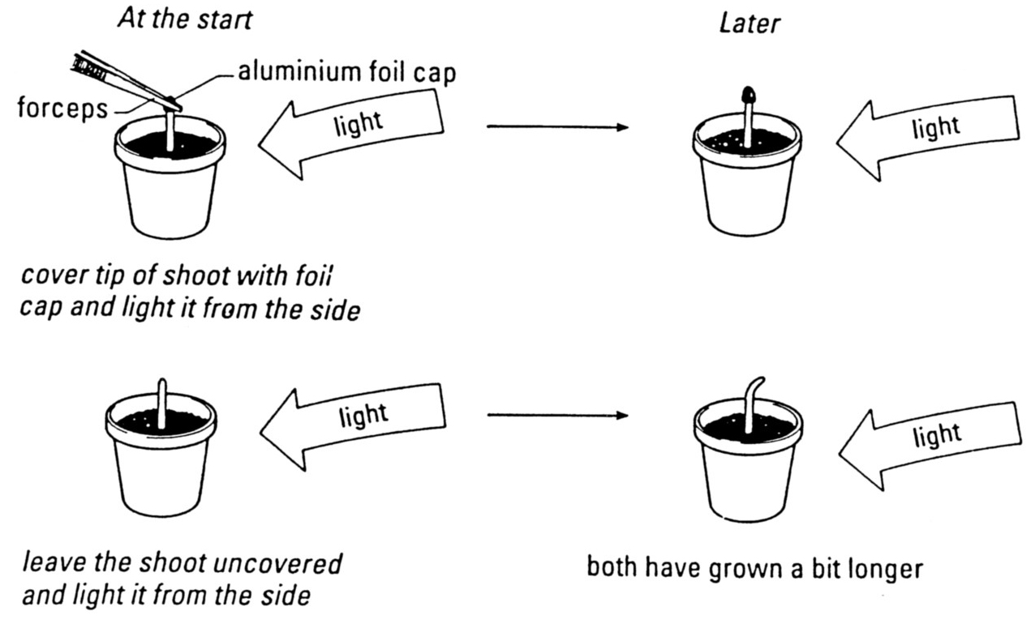
- Two shoots were used. The tip of one was covered with a foil cap. The other was left uncovered.

- Both shoots were exposed to light from one side.

- RESULT: Both shoots grow. One grows straight and the other grows towards the light.

1 What does this investigation tell you about how plants respond to the stimulus of light from one side?

Investigation 2

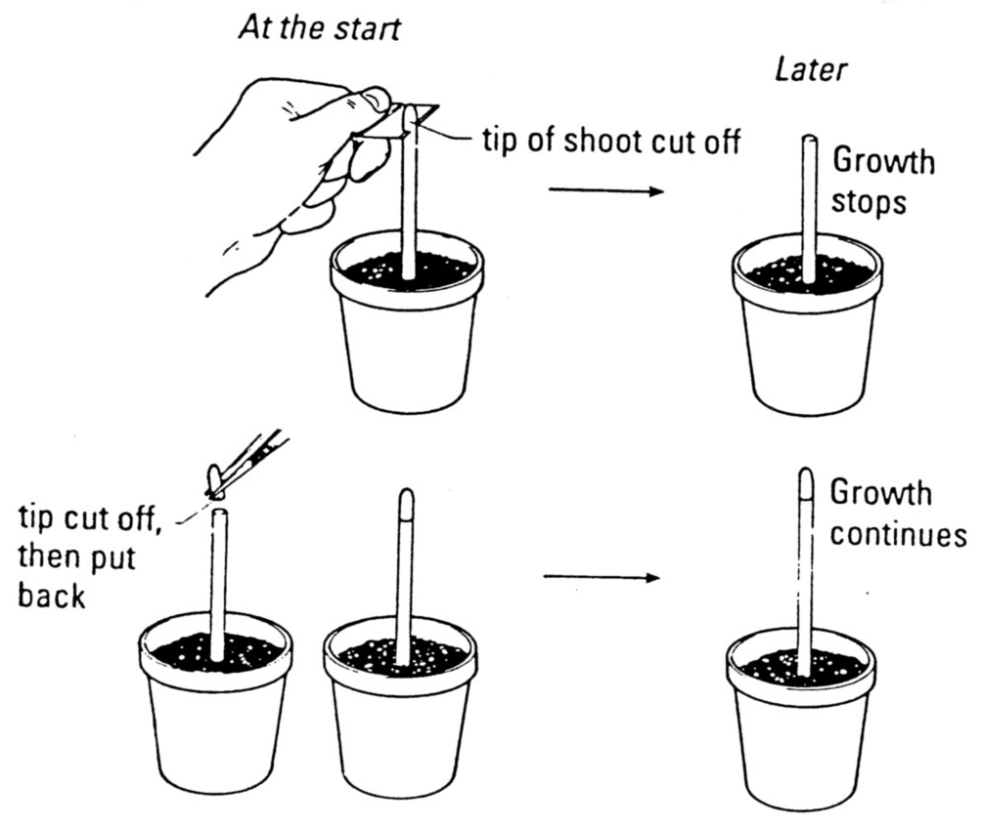
- Two shoots were used. From one the tip was cut off and discarded. From the other the tip was cut off and then put back.

- Both shoots were left to grow with light coming from all sides.

- RESULT: The shoot with the discarded tip stopped growing. The shoot whose tip was replaced continued to grow.

2 What does this tell you about how the tip of a plant shoot controls growth?

Investigation 3

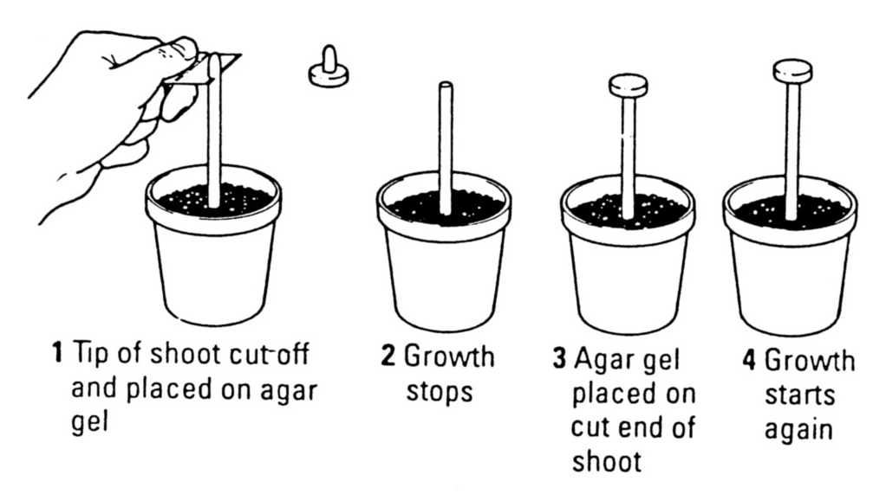
- As in Investigation 2, the tip of a shoot was cut off, but this time placed on an agar gel.

- RESULT: Growth of the coleoptile stopped.

- Then the agar gel was placed on the end of the cut shoot.

- RESULT: Growth started again.

3 How would you explain this result?

Investigation 4

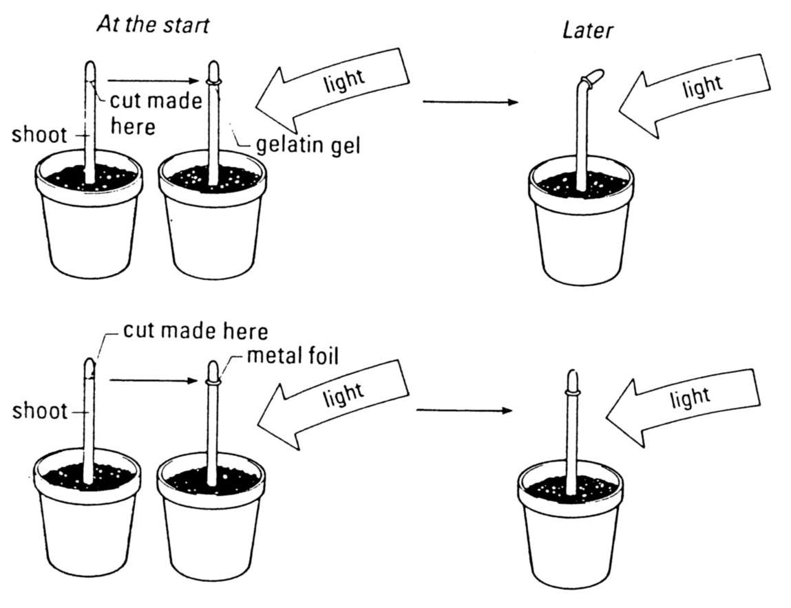
- Two shoots were used. The tips were cut off both.

- On one cut coleoptile, a piece of gelatin gel was placed and on the other, a piece of metal foil.

- The tips were balanced on top of the gel or foil.

- Both shoots were exposed to light from one side.

- RESULT: The shoot with the gelatin gel began to grow towards the light.

4 What does this result tell you about what might be happening within the shoot tip?

Investigation 5

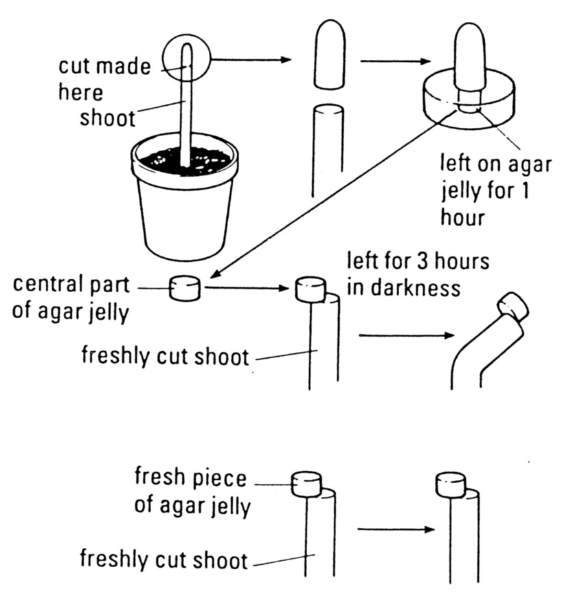
- The tip of a shoot growing in the light was cut off and placed on agar jelly for an hour.

- Two more shoots were then cut to remove their tips. The part of the jelly from right under the first tip shoot was then placed on the edge of one cut shoot, and a fresh piece of jelly on the edge of another.

- Both were left in the dark for 3 hours.

- RESULT: The shoot with fresh jelly did not bend. The shoot with agar from underneath a cut tip bent – with the side underneath the agar elongating compared to the other side.

5 How would you explain this result?

Answers

1 The first investigation suggests that it is the tip of the plant that is sensitive to light. In the absence of light, the shoot keeps growing, but does not grow towards the light.
2 This tells us that the tip is important in keeping a plant growing. Cutting off the tip stops growth. But replacing it starts growth happening again. If there was an electrical connection (like a nerve impulse) between the tip and the rest of the shoot, cutting it off and replacing it would probably break the connection. So, the message from the tip is likely to be a chemical message (like a hormone) not an electrical message.
3 This tells us that something from the shoot tip can pass into agar gel and that something (probably a chemical messenger) can re-start growth in a cut shoot.
4 This tells us that something from the shoot tip (probably a chemical messenger) can pass through gelatin, but not through foil.
5 This tells us that something from the shoot tip can make a shoot grow unevenly if it is put on one side of the shoot only. So, if a chemical messenger is at a higher concentration on one side of the shoot than the other, the shoot will grow more on one side and bend. It could bend towards a stimulus (such as light). Perhaps, somehow, light changes the concentration of the chemical messenger and this is how the shoot responds to the stimulus.

