Estimating the rate of transpiration from a plant cutting
This activity gives you a chance to evaluate a method for estimating the rate of water loss from a plant cutting.

Procedure
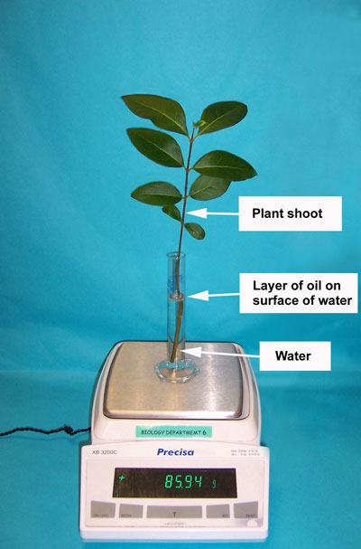
Set up some plant cuttings using this method, or use the ones that have been set up for you.
- Take 3 similar cuttings from the plant using scissors. Try to get a length of stem about 8 cm long with several leaves at the top.
- Place the plant cutting in the measuring cylinder.
- Adjust the water level to an exact level (for example 8 cm³) using the teat pipette.
- Make a note of the volume of water.
- Add about 1 cm³ of oil to the measuring cylinder using the second teat pipette, so that the oil sits on top of the water. Try not to get oil on the leaves.
- Place the apparatus on the balance and record the mass.
- On the measuring cylinder, write the starting volume of water, the mass of the apparatus and the time and date the apparatus was set up.
- Tape the measuring cylinder to a tray.
- Take 3 more cuttings at timed intervals for the next couple of days.

In the lesson you will…
- Weigh each set of apparatus and accumulate the data as a class set, recording how long ago the cylinders were set up, and how much the mass and volume have changed.

QUESTIONS
- Draw up a table to record the results of the investigation.

- What does the layer of oil do in this investigation?

- Calculate the changes in mass for each plant cutting.

- Calculate the changes in volume for each cutting.

- Estimate the average rate of water loss for all the cuttings.

- Have all the cuttings lost mass? Have all the cuttings lost volume? Has any cutting gained mass and lost volume?

- Do all the plants lose mass and volume during the investigation?

- Why is this?

- What could affect the rate of water loss from the cuttings?

- What do you think about this investigation? Do you think measuring mass or Volume is better for estimating water loss? Why? How could you improve the experiment to make the results more reliable?
ANSWERS
- Tables should record:
- when the cutting was set up
- how long each cutting has been in the water
- the start and finish volumes of water (and a space for calculation of the change in volume)
- the start and finish masses of the cylinders (and a space for calculation of the change in mass).

- The layer of oil stops water from evaporating directly from the cylinder. Water can only evaporate through the leaves of the plant.

- There should be steady losses of mass.

- There should be steady reductions of volume.

- Depends on class results.

- If the investigation works well, all the cuttings will have lost mass and volume and none will have gained mass and lost volume. However, the change in mass and volume is not only due to transpiration so there may be some anomalies. See Teaching notes.

- Let’s hope all the plants lose mass and volume during the investigation!

- The plant cutting takes in water through the cut end. Living plants normally take in water via their roots. The water travels up the transport tubes in the stem to the leaves and then evaporates from the surface of the cells inside the leaf. It then diffuses out through the stomata (or pores) in the leaf. This movement of water is called transpiration.

- The humidity of the air, or any breezes in the room could affect the rate of water loss from the cuttings. Healthy cuttings will lose water steadily. Unhealthy ones may not work so well.

- Student comments should include – more cuttings as samples and more accurate measurements of mass/ volume. Repeating the procedure will improve reliability. Measuring the mass of the cutting before and after could eliminate any error due to cutting growth.

