Digestion of starch: microbes

The purpose of this practical is:
- to compare the starch-digesting activity of two bacterial cultures with amylase solution
- to evaluate a quantitative method for assaying enzyme activity
- to introduce the use of enzymes in industrial processes.

Procedure
SAFETY:
Take care when working near the Bunsen burner flame. Concentrate on not contaminating the stock cultures, or introducing any unwanted microbes into your investigation.
Wear eye protection when handling iodine solution.
- Collect a starch-nutrient agar plate for your group. Your teacher will keep one for the class unopened as a control.
- Use a marker pen to mark four sections on the base. Label the sections A, B, C, and D. Label with your initials and the date.
- Write a key to record the treatment of each disc, and your results, for example

Area | Treatment | Diameter of clear zone
A | Bacillus subtilis
B | Escherichia coli
C | 0.1% amylase solution
D | Distilled water

- Pass the forceps through a Bunsen burner flame. Allow them to cool and use them to pick up one of the paper discs.

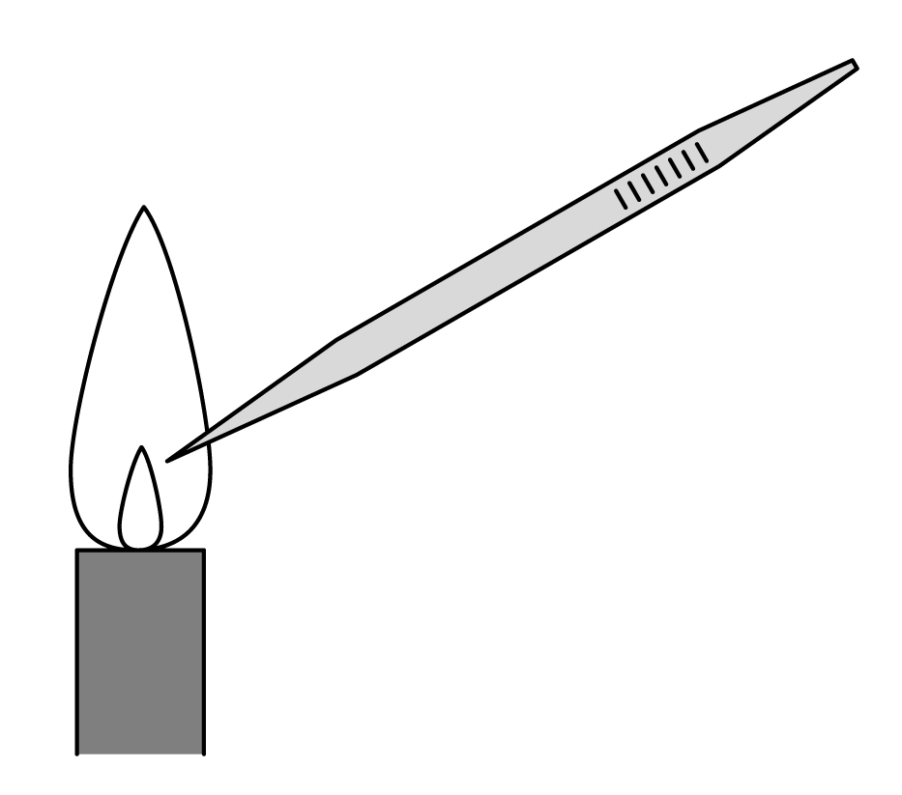
- Open a bottle containing bacterial culture (or remove the cotton wool stopper from the test tube). Flame the neck and dip the disc into the broth. Allow excess to drip off. Flame the neck again and replace the top or stopper. Transfer the disc to the middle of the correct section on the agar plate.
- Repeat d and e using another disc and the other bacterial culture.
- Repeat d and e using another disc and the amylase solution.
- Repeat d and e using another disc and the distilled water.
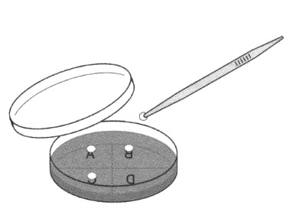
- Place the forceps in a discard beaker.
- Tape up the dish.
- Incubate the plates.
- After 2-3 days, open the Petri dish and use a dropper to put in just enough iodine solution to cover the surface of the agar. Replace the lid. (It is safe to open the plate because your technical staff have killed any bacteria growing there.)
- Put the dish on squared paper. Measure and record the diameter of any clear zones around the discs. A wider diameter suggests a greater concentration of amylase.

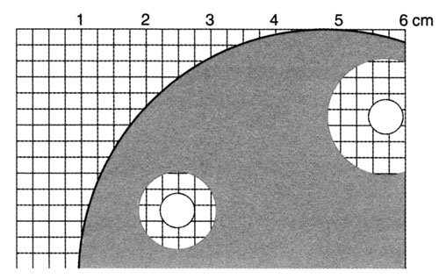

QUESTIONS
- What is the purpose of the paper disc soaked in distilled water in this investigation?

- What do you know about the enzyme amylase?

- What does the iodine solution do to the agar plate?

- Which is the most active starch-digesting sample in your test?

- Industrial processes often use enzyme extracts rather than bacterial cultures to digest starch. What would be the advantage of an enzyme extract over a bacterial culture? Would it matter more if the product is a foodstuff or a fuel?

- You have measured the diameter of agar cleared by the enzyme and used this to measure the enzyme activity. What would you do to develop the accuracy of this technique? What are its limitations? How could you improve it?

- How might you measure the activity of:
- a protein-digesting enzyme
- a fat-digesting enzyme?

ANSWERS
- The paper disc soaked in distilled water is a control. It shows us that any change in the starch is due to what we have soaked into the papers, not to the paper discs themselves or any other aspect of the technique.

- Amylase is an enzyme that digests starch and produces sugars. (Different amylases cleave the starch chain in different places and produce different products. The level of detailed knowledge required is left to the teacher!).

- Iodine solution turns starch blue-black. It clearly shows up where there is still starch in the plate and will not stain areas where all the starch has been digested. If you see a pale pink/ purple colour at the edges of the cleared areas, that is amylopectin.

- Depends on test results.

- Enzyme extracts will be easy to ‘stop’ in their action by heating and will not leave complex contaminants behind. They will be easier to keep sterile. This is especially important if the product is a foodstuff. However, bacterial cultures would continue to produce amylase, whereas an extract will have a finite life.

- You could develop the accuracy in lots of ways. Try to calibrate – with known concentrations of enzyme and consistent incubation processes. See what effect different concentrations of starch have. Limitations: Is the edge of the cleared area easy to see? Could you make it clearer with more concentrated starch or less concentrated? Does the result vary with varying incubation times or varying starch content?

- A protein-digesting enzyme could dissolve a protein jelly, liquefying it.
A fat-digesting enzyme would clarify an emulsion (within a jelly).

