Digestion of protein: microbes

The purpose of this practical is:
- to compare the protein-digesting activity of two microbial cultures with trypsin solution
- to evaluate a quantitative method for assaying enzyme activity
- to introduce the use of enzymes in industrial processes.

Procedure
SAFETY:
In this investigation, your sterile technique is really important. Take care when working near the Bunsen burner flame. Concentrate on not contaminating the stock cultures, or introducing any unwanted microbes into your investigation.
- Collect a milk-agar plate for your group. Your teacher will keep one for the class unopened as a control.
- Use a marker pen to mark four sections on the base. Label the sections A, B, C, and D. Label with your initials and the date.
- Write a key to record the treatment of each disc, and your results, for example

Area | Treatment | Diameter of clear zone
A | Bacillus subtilis
B | Saccharomyces cerevisiae
C | 0.1% trypsin solution
D | Distilled water

- Pass the forceps through a Bunsen burner flame. Allow them to cool and use them to pick up one of the paper discs.
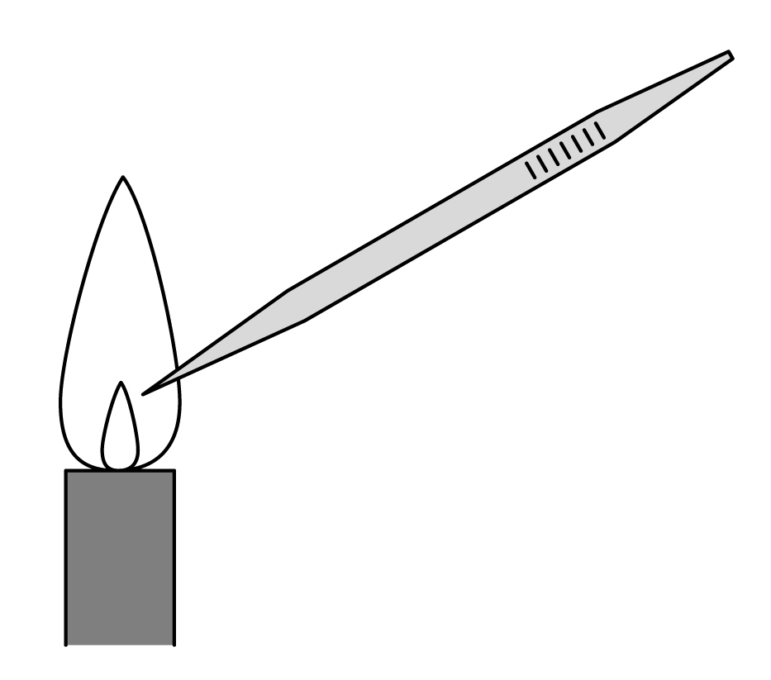

- Open a bottle containing bacterial culture (or remove the cotton wool stopper from the test tube). Flame the neck and dip the disc into the broth. Allow excess to drip off. Flame the neck again and replace the top or stopper. Transfer the disc to the middle of the correct section on the agar plate.
- Repeat d and e using another disc and the fungal culture.
- Repeat d and e using another disc and the trypsin solution.
- Repeat d and e using another disc and the distilled water.

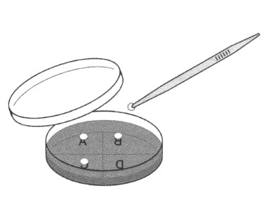

- Place the forceps in a discard beaker.
- Tape up the dish and incubate the plates.
- Put the dish on squared paper. Measure and record the diameter of any clear zones around the discs. A wider diameter suggests a greater concentration of protease. Protease breaks down proteins into soluble amino acids. Do not open the plates.

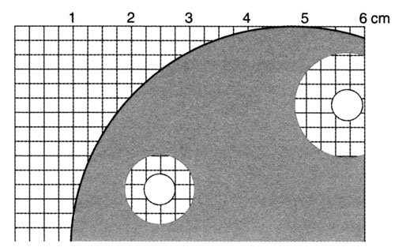

QUESTIONS
- What is the purpose of the paper disc soaked in distilled water in this investigation?

- What do you know about the enzyme trypsin?

- What do the proteases do to the milk in the agar plate?

- Which is the most active protease in your test?

- You have measured the diameter of agar cleared by the enzyme and used this to measure the enzyme activity. What would you do to develop the accuracy of this technique? What are its limitations? How could you improve it?

- How might you measure the activity of:
- a starch-digesting enzyme?
- a fat-digesting enzyme?

ANSWERS
- The paper disc soaked in distilled water is a control. It shows us that any change in the milk-agar is due to what we have soaked into the papers, not to the paper discs themselves or any other aspect of the technique.

- Trypsin is an enzyme that hydrolyses protein to amino acids. (Different proteases cleave protein chains in different places and produce different products. The level of detailed knowledge required is left to the teacher!)

- Areas of the plate are cleared as casein (a protein in milk) is digested which then clarifies the mixture.

- Depends on test results.

- You could develop the accuracy in lots of ways. Try to calibrate – with known concentrations of enzyme and consistent incubation processes. Try suspensions of other proteins. Limitations: Is the edge of the cleared area easy to see? Could you make it clearer? Or read it mechanically? Does the result vary much with varying incubation times?

- A starch-digesting enzyme would change starch to sugars. Starch could be detected with iodine. Absence of starch gives an orange-brown colour.
A fat-digesting enzyme would clarify an emulsion (within a jelly).

