Biodiversity in your backyard!

Procedure
SAFETY:
Follow all your teacher’s instructions and behave sensibly while working outside.
Look out for any unexpected litter in the area that might cut you and any animal droppings.
Wash your hands carefully at the end of the outdoor work, especially before eating.
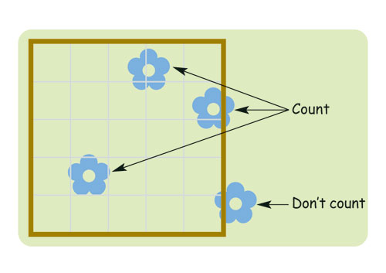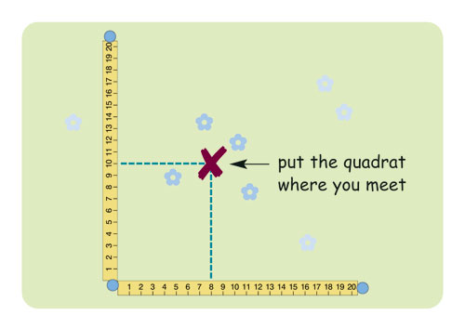© FSC

Species present
Quadrat number
1
2
3
4
5
6
7
8
9
10
Numbers / percentages in each quadrat

