An enzyme-catalysed synthesis
The purpose of this activity is:
- to extract an enzyme from biological material
- to investigate the action of the enzyme on different substrates
- to show that some enzymes catalyse reactions resulting in synthesis of biomolecules

Procedure
SAFETY: Use the centrifuge according to instructions. Wear eye protection when handling iodine solution.

Investigation
Preparation
- Prepare the colorimeter by putting a known volume of water (say 3 cm³) into your colorimeter cuvettes or bottle. Add 0.5 cm³ (or 1.0 cm³) of iodine solution and swirl to mix well. Make sure this liquid is deep enough in the vessel to provide an accurate reading in your colorimeter (by comparing with a full colorimeter vessel of the same solution). Use a yellow filter as we will be following the formation of a blue starch-iodide complex (peak of absorption 580-600 nm). Record the reading from the iodine solution as the ‘zero’ reading for this procedure. Set up ‘clean’ cuvettes to follow the reaction with 2 cm³ of water and 0.5 (or 1.0 cm³) of iodine solution. You will add 1.0 cm³ of starch solution to each of these.

Investigation
- Take two medium-sized potatoes, peel and cut into small pieces. Crush with a pestle and mortar or use a blender. Add water sparingly so that the resulting mash is just liquid enough to be poured from the container.
- Pour the crushed potato quickly through a single layer of muslin or nylon stocking.
- Transfer the extract to centrifuge tubes. Spin in a bench centrifuge for 5 minutes at the highest speed to separate the starch granules.
- After spinning, take one drop of clear liquid from the top of each tube. Test each drop on a white tile with iodine solution. If the blue colour characteristic of starch appears, centrifuge for a further 5 minutes.
- Repeat the iodine test and, if necessary, continue to centrifuge until no starch is detectable in the samples of clear liquid. Once the liquid is free of starch, carefully pour the clear liquid from each centrifuge tube into a single container. If this is to be kept overnight, stopper and refrigerate the container.
- Label 4 test tubes. Use a syringe to put 5 cm³ of glucose-1-phosphate into a test tube and place it in a water-bath at 25 °C. Use fresh syringes to measure 5 cm³ of the other substrates into the other test tubes in the same water-bath. Record which substrate is in which tube.
- Use a syringe to measure four 5 cm³ samples of the clear potato extract into each of four more test tubes and place in the water bath at 25 °C.
- Add 5 cm³ of potato extract from a tube in the water bath to each tube of substrate solution. Start the stopclock.
- After two minutes, take a single drop of the potato extract/ glucose-1-phosphate mixture and mix it with a drop of iodine on a white tile. Look for a very slight colour change. If there is none, repeat at two minute intervals as recorded by the stopclock.
- As soon as the slightest trace of blue or grey colour appears on the tile, remove 1.0 cm³ from the mixture into your cuvette or colorimeter vessel (containing 2 cm³ of water and 0.5 cm³ or 1.0 cm³ of iodine solution). Mix well and record the colorimeter reading and the time.
- Using fresh iodine solution, carry out similar measurements with the other three extract/ substrate mixtures.
- Check the amount of enzyme extract/ substrate mixture left and arrange to take more samples at regular intervals. Try to take at least eight readings for each extract/ substrate mix. If colorimeter readings are changing rapidly from one sample to the next with a particular substrate, concentrate on that mixtures and take samples as often as possible. Then return to the other extract/ substrate mixtures.
- For each measurement, record the substrate, time, apparent colour (to your eye) and colorimeter reading.
- Convert the meter readings into starch concentrations using a calibration curve

QUESTIONS
- Describe the appearance of the mixtures at the end of the investigation. Which substrates produced starch when potato extract was added?

- What evidence you have obtained will enable you to deduce whether or not starch synthesis is a simple reversal of starch digestion?

- What other substrates can you think of which you could test with this potato enzyme?

- Plot a graph of starch concentration against time.

- How would you describe the early phase of starch synthesis? Suggest a hypothesis to account for your investigation.

- How could you find out if there is a similar pattern to starch digestion?

ANSWERS
- All the mixtures may appear darker at the end of the investigation. This is due to the action of polyphenol oxidase and is the same process that causes cut apples (and potatoes) to become brown. The mixture containing glucose-1-phosphate should produce starch.

- Digestion of starch produces maltose and glucose. However, these are not catalysed to synthesise starch – only the phosphorylated sugar is effective. This shows that starch synthesis is not a simple reversal of starch digestion.

- Other substrates worth testing could be related phosphorylated sugar such as galactose-1-phosphate or xylose-1-phosphate. Or glucose solution containing ATP, or inorganic phosphate, or glucose-6-phosphate could be worth exploring.

- A graph of starch concentration against time should look like this

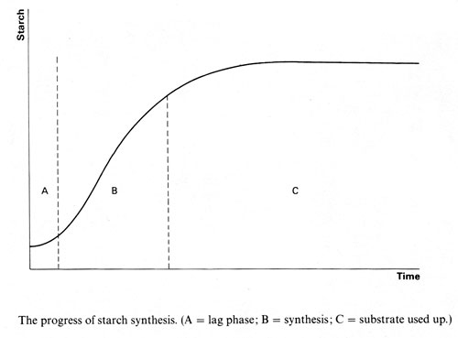

- The early phase of starch synthesis is a ‘lag phase’. The lag phase suggests that the reaction is autocatalytic.

- You could find out if there were a similar pattern to starch digestion by setting up a similar investigation with a digestive enzyme extract and following the rate at which starch concentration in the mixture falls away.

