Using a spirometer to investigate human lung function

The purpose of this activity is:
- to show how a spirometer can be used to find the vital capacity of lungs and to calculate important subdivisions of this capacity.
- to show how to interpret the trace resulting from use of a spirometer
- to consider how to use a spirometer to estimate metabolic rate.

Procedure
SAFETY:
Do not use a spirometer unless supervised by a teacher.
If you are using the spirometer and you experience any distress or difficulty breathing, remove the nose-clip and mouthpiece and detach yourself from the machine immediately.
Do not use the spirometer for more than a few minutes at a time.
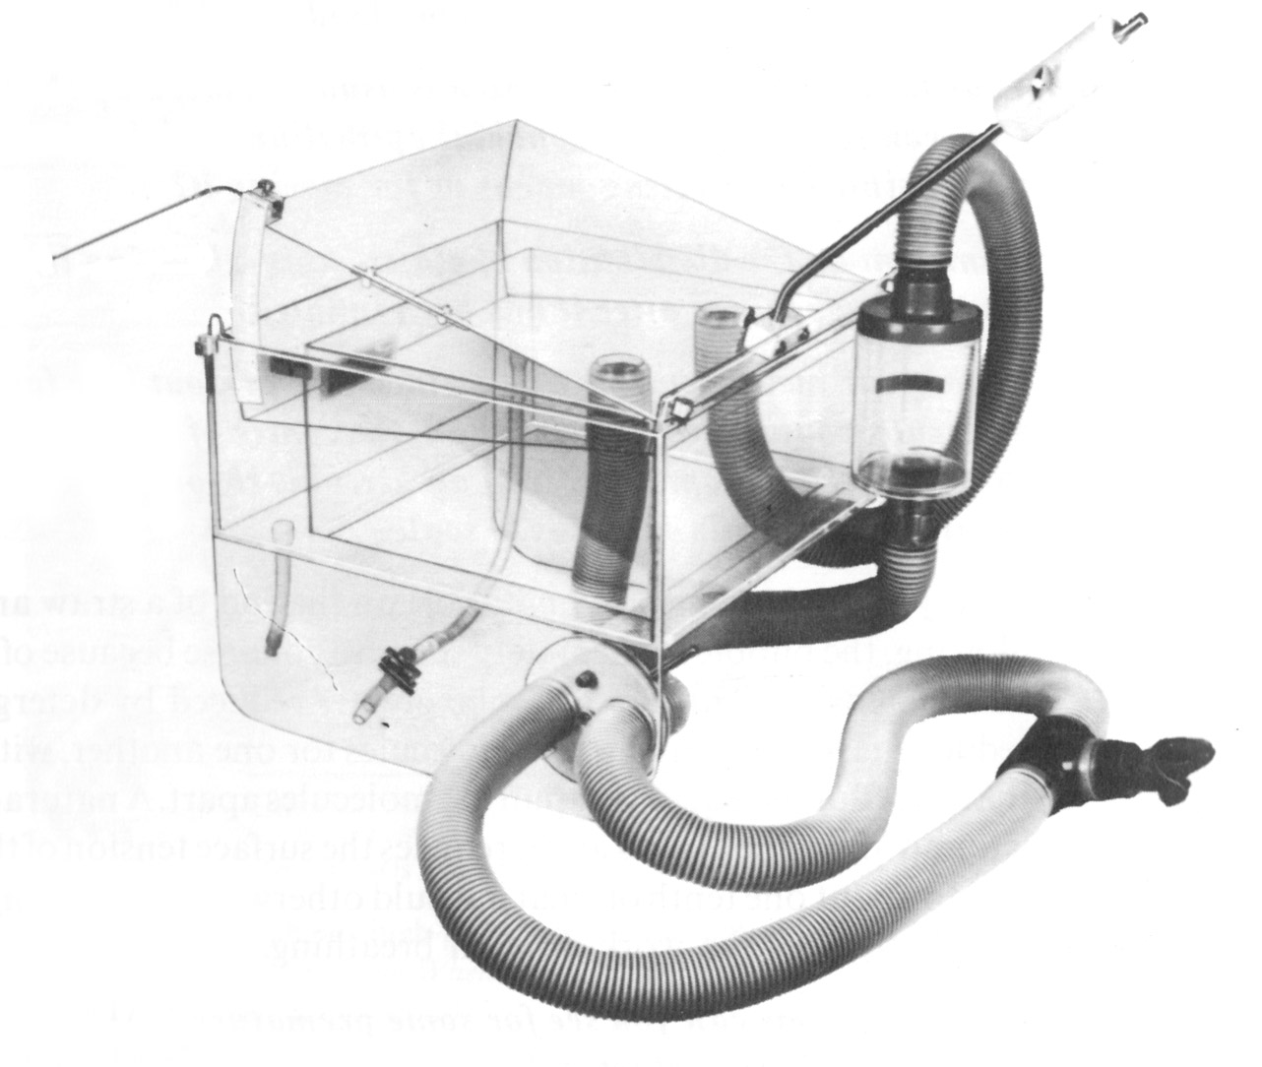
© Nuffield 1996

QUESTIONS
- As a subject breathes in from the apparatus, what will happen to the lid of the chamber? If a pen or datalogger is attached to the lid, how will the trace it makes change as the subject breathes in?

- As a subject breathes out into the chamber, what will happen as the air goes through the carbon dioxide absorbent granules?

- Will the lid go back up to its starting position if the subject breathes out normally?

- As the subject breathes steadily, they will use up oxygen and replace it with carbon dioxide. What will happen to the total volume of air in the spirometer?

Investigation: collecting data about normal breathing
- Under your teacher’s supervision, collect data by making a trace as a subject breathes normally for 5-10 breaths.
- After a normal out breath, ask the subject to breathe in as far as possible for one in breath, then breathe normally for two or three breaths.
- After a normal in breath, ask the subject to breathe out as far as possible. They don’t have to breathe out quickly, but get them to try to breathe out as much as they can.
- After this maximum out breath, ask the subject to breathe normally for another 5-10 breaths. After an out breath, disconnect them from the spirometer.
- Scan and print or make photocopies of the trace for all the people in your working group. It should look something like this.

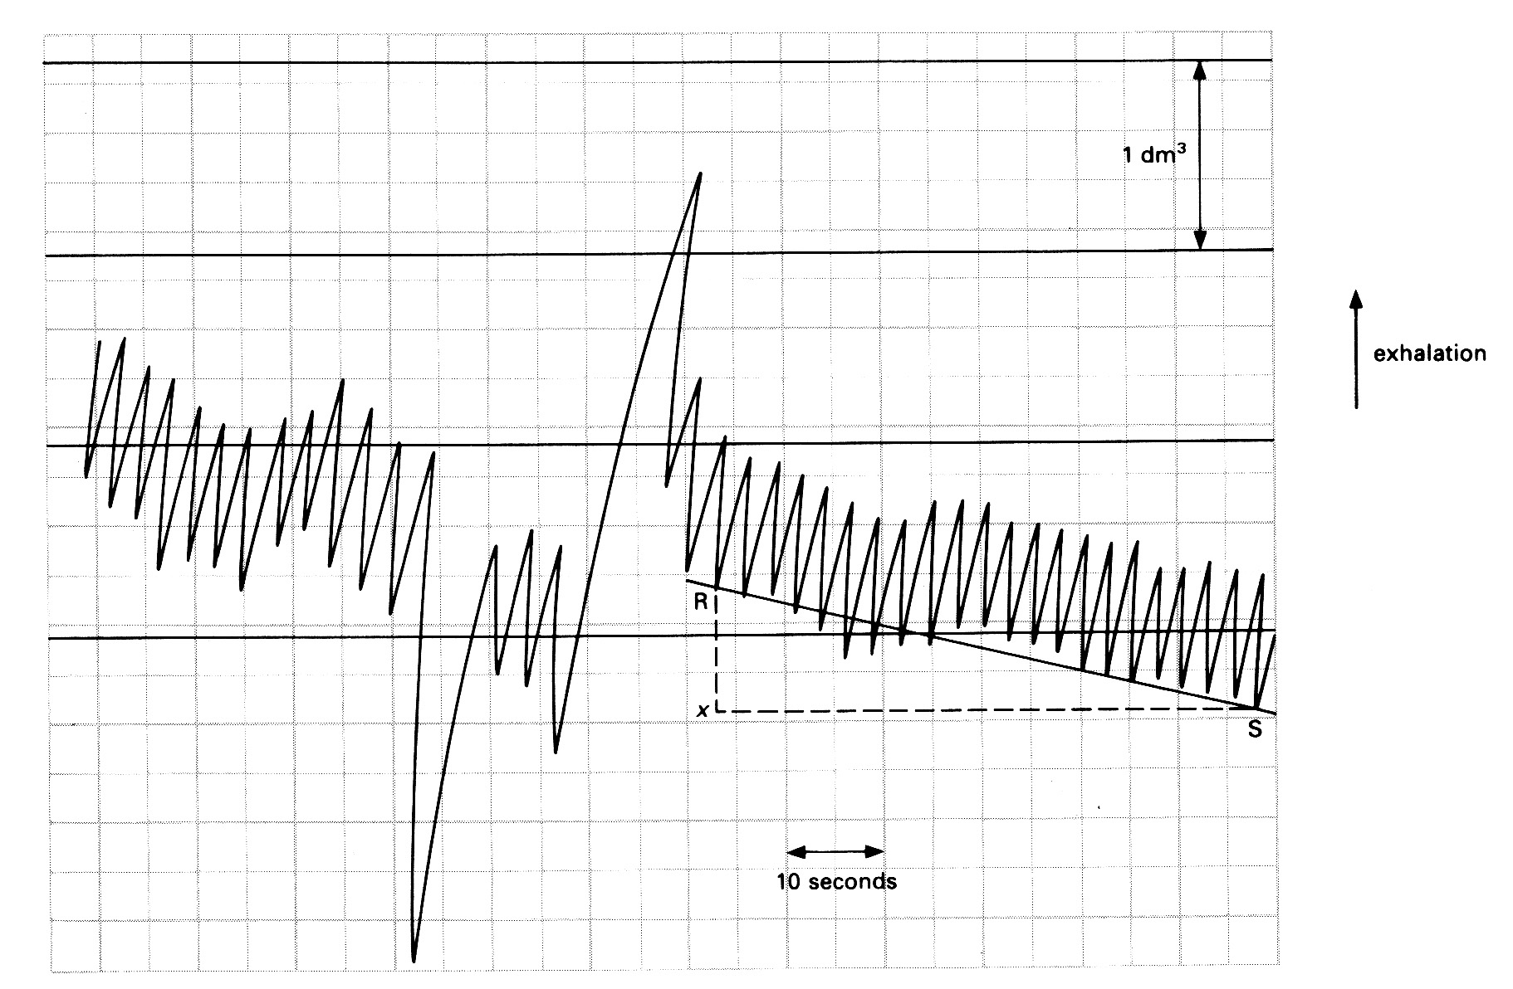
QUESTIONS
- Use your spirometer trace, or the one above, to calculate the following measures of lung function for the subject:
- tidal volume
- inspiratory reserve volume
- expiratory reserve volume
- vital capacity

- Estimate the total lung capacity by multiplying the expiratory reserve volume by six.

- Calculate the residual volume by subtracting the vital capacity from the total lung capacity.

This standard curve showing these measures might help you.
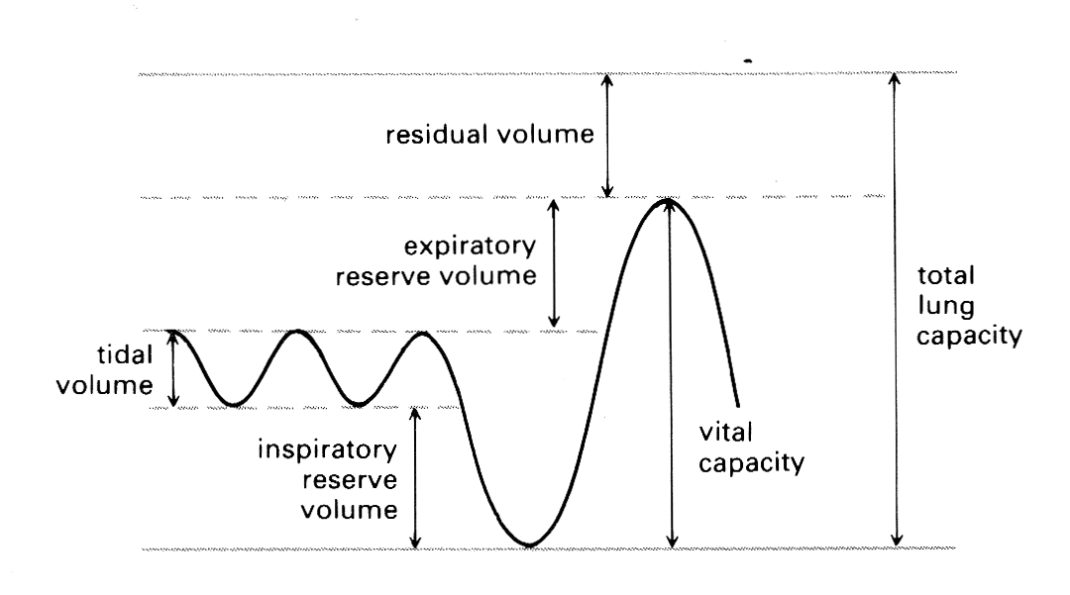

Investigation: Interpreting traces
- Collect spirometer traces from subjects in different situations – for example, after taking light exercise.
- Compare them with the standard trace you have already obtained.
- Describe the differences between the spirometer traces and explain what they have told you about human lung function and oxygen consumption.

QUESTIONS
- These two traces are from a subject immediately after exercise and the same subject 2 minutes later. The grids are on the same scale as the trace given above.

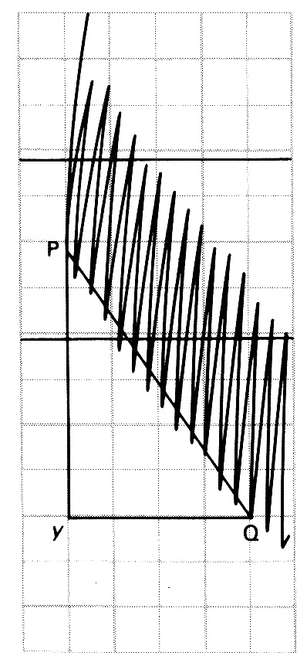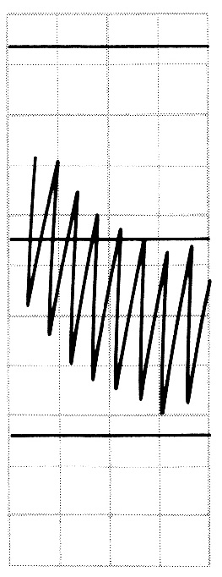
Condition of subject | Time period covered by trace (seconds) | Oxygen consumed in that time (litres) | Oxygen consumption (litres per second)
at rest
immediately after exercise
in the time period 2 minutes after exercise

Calculate the rate of oxygen consumption for this subject:
- at rest (from trace above showing normal breathing)
- immediately after exercise
- in the time period 2 minutes after exercise.

To do this, each time, draw a triangle on the part of the trace you are using (this is done for you in the first two traces). Then measure the drop in the trace and use the calibration factor to convert this to oxygen consumption. Then measure the time across the trace (and use the scale to read this in seconds). Divide one by the other to get consumption of oxygen in cm³ per second. Multiply by 60 x 60 to get consumption per hour and divide by 1000 to get consumption in litres.
- What do these traces, and these calculations tell you about how the subject uses oxygen?

ANSWERS Preparation
- As a subject breathes in, the lid of the chamber falls and a pen or datalogger attached to it will make a downward track on the trace.

- As they breathe out into the chamber, carbon dioxide in the exhaled air will be absorbed by the carbon dioxide absorbent, and the total volume of air going back into the chamber will be less than was breathed in.

- The lid will not quite go back up to its starting position as there is now less air in the chamber – because the carbon dioxide has been absorbed.

- Over several breaths the volume of air in the spirometer will drop – by an amount equal to the amount of oxygen used up by the subject.

ANSWERS Collecting data about normal breathing
- These can be read off the graph.

- Has the calculation been done correctly? Adult human value is around 5.5 to 6.0 dm³.

- Has the calculation been done correctly? Adult human value is around 1.2 dm³.

ANSWERS Interpreting traces
- Examples of the data collected from the traces are given here.

Condition of subject | Time period covered by trace (seconds) | Oxygen consumed in that time (cm³) | Oxygen consumption (litres per second)
at rest | 55 | 656.4 | 0.012
immediately after exercise | 20 | 1497.4 | 0.075
in the time period 2 minutes after exercise | 13 | 564.1 | 0.051

- These traces and calculations tell us that even after exercise, our oxygen consumption is elevated. This is because our lungs and circulatory system cannot provide all the oxygen needed for muscle activity during exercise and must continue to supply oxygen after the exercise is finished to convert metabolites that have built up in the muscle. This is called paying off an oxygen debt.

